Question-1
The Deep Learning first layer is called the?
Option A | hidden layer
Option B | outer layer
Option C | inner layer
Option D | Input layer
Solution
Correct Option/s | D) input layer
Solution Explanation | The first layer is called the Input Layer. The last layer is called the Output Layer. All layers in between are called Hidden Layers.

Question-2
Error signals flow a simple feedforward neural network in the _____ direction
Option A | Forward
Option B | Backwards
Option C | Both Directions
Option D | None of the above
Solution
Correct Option/s | B) Backwards
Solution Explanation | Backpropagation, or backward propagation of errors, is an algorithm that is designed to test for errors working back from output nodes to input nodes. It is an important mathematical tool for improving the accuracy of predictions in data mining and machine learning.

Question-3
The complexity of backpropagation in ANN is dependent upon _____________?
Option A | Number of inputs
Option B | Number of neurons
Option C | Number of nodes
Option D | Number of layers
Solution
Correct Option/s | D) Number of layers
Solution Explanation | The number of layers and circuit complexity of neural networks are in direct proportion

Question-4
Feedforward networks are used for?
Option A | Pattern mapping
Option B | Pattern association
Option C | Pattern classification
Option D | All of the mentioned
Solution
Correct Option/s | D) All of the mentioned
Solution Explanation | Feedforward networks are used for pattern mapping, pattern association, and pattern classification.

Question-5
Feedback connection strengths are usually?
Option A | Fixed
Option B | Variable
Option C | Both fixed or variable type
Option D | None of the mentioned
Solution
Correct Option/s | A) Fixed
Solution Explanation | Feedback connection strength are usually fixed & linear to reduce complexity.

Question-6
What is the primary purpose of the activation function in a neural network?
Option A | To normalize the input data
Option B | To determine the learning rate of the network
Option C | To introduce non-linearity into the network
Option D | To control the number of hidden layers in the network
Solution
Correct Option/s | C) To introduce non-linearity into the network
Solution Explanation | Activation functions play an integral role in neural networks by introducing nonlinearity. This nonlinearity allows neural networks to develop complex representations and functions based on the inputs that would not be possible with a simple linear regression model.

Question-7
What is backpropagation in the context of neural networks?
Option A | The process of adjusting the weights and biases based on prediction errors
Option B | The method used to prevent overfitting in a neural network
Option C | The activation function applied to the output layer of a neural network
Option D | The technique for encoding categorical variables in a neural network
Solution
Correct Option/s | A) The process of adjusting the weights and biases based on prediction errors
Solution Explanation | Backpropagation, or backward propagation of errors, is an algorithm that is designed to test for errors working back from output nodes to input nodes. It is an important mathematical tool for improving the accuracy of predictions in data mining and machine learning.

Question-8
Which layer of a neural network is responsible for making the final predictions?
Option A | Input
Option B | Output
Option C | Hidden
Option D | Bias
Solution
Correct Option/s | B) Output Layer
Solution Explanation | The output layer is the final layer in the neural network where desired predictions are obtained. There is one output layer in a neural network that produces the desired final prediction. It has its own set of weights and biases that are applied before the final output is derived.

Question-9
Which of the following cannot be used as a loss function for regression tasks?
Option A | Mean Squared Error
Option B | Mean Absolute Error
Option C | Binary Cross Entropy
Option D | Root Mean Squared Error
Solution
Correct Option/s | C) Binary Cross Entropy
Solution Explanation | Binary cross entropy (also known as logarithmic loss or log loss) is a model metric that tracks incorrect labeling of the data class by a model in binary classification problems, penalizing the model if deviations in probability occur into classifying the labels.

Question-10
Which of the following activation functions is commonly used in the output layer of a binary classification problem?
Option A | ReLU
Option B | Leaky ReLU
Option C | Sigmoid
Option D | Tanh
Solution
Correct Option/s | C) Sigmoid
Solution Explanation | Sigmoid is commonly used in the output layer of a binary classification problem

Question-11
Which of the following activation functions can lead to vanishing gradients?
Option A | ReLU
Option B | Tanh
Option C | Leaky ReLU
Option D | None of the above
Solution
Correct Option/s | B) Tanh
Solution Explanation | Tanh can lead to vanishing gradients

Question-12
After training a neural network, you observe a large gap between the training
accuracy (100%) and the test accuracy (42%). Which of the following methods is
commonly used to reduce this
Option A | Generative Adversarial Netw
Option B | Dropout Layer
Option C | Sigmoid Activation
Option D | RMSprop optimizer
Solution
Correct Option/s | B) Dropout Layer
Solution Explanation | The Dropout layer randomly sets input units to 0 with a frequency of rate at each step during training time, which helps prevent overfitting.

Question-13
Which activation function converts all negative values to zero?
Option A | Sigmoid
Option B | ReLU
Option C | Tanh
Option D | Softplus
Solution
Correct Option/s | B) ReLU
Solution Explanation | ReLU looks like this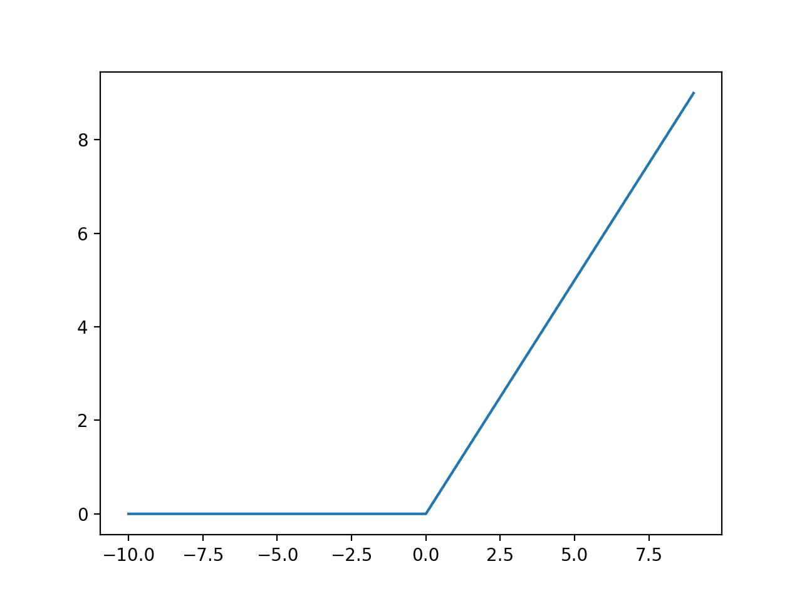

Question-14
Which activation function is linear and does not introduce non-linearity in a neural network?
Option A | Sigmoid
Option B | ReLU
Option C | Tanh
Option D | Linear
Solution
Correct Option/s | D) Linear
Solution Explanation | Linear

Question-15
Which of the following optimizers does NOT use momentum in its update rule?
Option A | SGD (Stochastic Gradient Descent)
Option B | Adam (Adaptive Moment Estimation)
Option C | RMSprop (Root Mean Square Propagation)
Option D | Adagrad (Adaptive Gradient)
Solution
Correct Option/s | A) SGD
Solution Explanation | Momentum is an extension to the gradient descent optimization algorithm that allows the search to build inertia in a direction in the search space and overcome the oscillations of noisy gradients and coast across flat spots of the search space.  It is an extension and is not involved in SGD by default.

Question-16
Which optimizer is known for its ability to handle sparse gradients?
Option A | Adam (Adaptive Moment Estimation)
Option B | RMSprop (Root Mean Square Propagation)
Option C | Adagrad (Adaptive Gradient)
Option D | AdaDelta (Adaptive Delta)
Solution
Correct Option/s | C) Adagrad (Adaptive Gradient)
Solution Explanation | Adagrad is an optimizer that is known for its ability to handle sparse gradients effectively. In traditional gradient-based optimization algorithms like SGD (Stochastic Gradient Descent), the learning rate is applied uniformly to all parameters during the update step. However, in the presence of sparse gradients, some parameters may receive very few updates, leading to slow convergence or learning.

Question-17
Which optimizer is an extension of Adagrad that aims to reduce its aggressive, monotonically decreasing learning rate?
Option A | Adadelta (Adaptive Delta)
Option B | RMSprop (Root Mean Square Propagation)
Option C | Adamax (Adam with infinity norm)
Option D | Adam (Adaptive Moment Estimation)
Solution
Correct Option/s | A) Adadelta (Adaptive Delta)
Solution Explanation | AdaDelta is a stochastic optimization technique that allows for per-dimension learning rate method for SGD. It is an extension of Adagrad that seeks to reduce its aggressive, monotonically decreasing learning rate.

Question-18
Which of the following regularization techniques adds a penalty term to the loss function based on the magnitude of the weights?
Option A | Dropout
Option B | L1 regularization (Lasso)
Option C | L2 regularization (Ridge)
Option D | Batch normalization
Solution
Correct Option/s | C) L2 regularization
Solution Explanation | Ridge regression adds “squared magnitude” of coefficient as penalty term to the loss function.

Question-19
Which regularization technique normalizes the activations of each layer by adjusting the mean and variance?
Option A | Dropout
Option B | L1 regularization (Lasso)
Option C | L2 regularization (Ridge)
Option D | Batch normalization
Solution
Correct Option/s | D) Batch Normalization
Solution Explanation | Batch normalization is a technique used to improve the performance of a deep learning network by first removing the batch mean and then splitting it by the batch standard deviation.

Question-20
Which regularization technique can be applied to both the weights and biases of a neural network?
Option A | Dropout
Option B | L1 regularization (Lasso)
Option C | L2 regularization (Ridge)
Option D | Batch normalization
Solution
Correct Option/s | C) L2 Regularization
Solution Explanation | C) L2 Regularization

